Problems
1-14 Gina Fox has started her own company, Foxy Shirts, which manufactures imprinted shirts for special occasions. Since she has just begun this operation, she rents the equipment from a local printing shop when necessary. The cost of using the equipment is $350. The materials used in one shirt cost $8, and Gina can sell these for $15 each.
(a) If Gina sells 20 shirts, what will her total revenue be? What will her total variable cost be?
Total revenue = revenue from one shirt * number of shirts
Revenue from one shirt = $15* 20
= $300
Total variable cost = variable cost of one shirt * number of shirts
Total variable cost = $8 * 20
= $160
(b) How many shirts must Gina sell to break even? What is the total revenue for this?
Fixed Cost = Cost of Equipment = $350
Selling Price per Unit = 15
Variable Cost per Unit = $8
Break Even Point = Fixed Cost/ (Selling Price-Variable Cost)
Break Even Point = 350/ (15-8)
Break Even Point = 350/7
Break Even Point = 50 shirts
1-15 Ray Bond sells handcrafted yard decorations at county fairs. The variable cost to make these is $20 each, and he sells them for $50. The cost to rent a booth at the fair is $150. How many of these must Ray sell to break even?
Fixed Cost = renting booth = $150
Selling Price per Unit = $50
Variable Cost per Unit = $20
Break Even Point = Fixed Cost/ (Selling Price-Variable Cost)
Break Even Point = 150/ (50-20)
Break Even Point = 150/30
Break Even Point = 5 decorations
1-16 Ray Bond, from Problem 1-15, is trying to find a new supplier that will reduce his variable cost of production to $15 per unit. If he was able to succeed in reducing this cost, what would the break-even point be?
Fixed Cost = renting booth = $150
Selling Price per Unit = $50
Variable Cost per Unit = $15
Break Even Point = Fixed Cost/ (Selling Price-Variable Cost)
Break Even Point = 150/ (50-15)
Break Even Point = 150/35
Break-even point = 4.286 decorations
1-17 Katherine D'Ann is planning to finance her college education by selling programs at the football games for State University. There is a fixed cost of $400 for printing these programs, and the variable cost is $3. There is also a $1,000 fee that is paid to the university for the right to sell these programs. If Katherine was able to sell programs for $5 each, how many would she have to sell in order to break even?
Fixed Cost of printing= $400
Fixed cost of paying fee = $1000
Total fixed cost = ($400 + $1000) = $1400
Selling Price per Unit = $0
Variable Cost per Unit = $3
Break Even Point = Fixed Cost/ (Selling Price-Variable Cost)
Break Even Point = 1400/ (50-3)
Break Even Point = 1400/2
Break-even point = 700 programs

1-18 Katherine D'Ann, from Problem 1-17, has become concerned that sales may fall, as the team is on a terrible losing streak, and attendance has fallen off. In fact, Katherine believes that she will sell only 500 programs for the next game. If it was possible to raise the selling price of the program and still sell 500, what would the price have to be for Katherine to break even by selling 500?
Selling price = p
Break even = 500
Fixed cost = 1400
Selling price will be calculated as:
500p = 3*500 +1400
p = $5.8
Selling price to breakeven = $5.8
3-17 Kenneth Brown is the principal owner of Brown Oil, Inc. After quitting his university teaching job, Ken has been able to increase his annual salary by a factor of over 100. At the present time, Ken is forced to consider purchasing some more equipment for Brown Oil because of competition. His alternatives are shown in the following table:
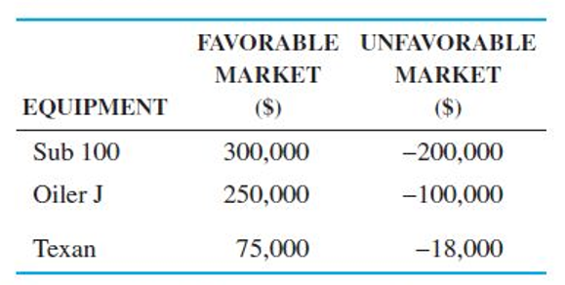
For example, if Ken purchases a Sub 100 and if there is a favorable market, he will realize a profit of $300,000. On the other hand, if the market is unfavorable, Ken will suffer a loss of $200,000. But Ken has always been a very optimistic decision maker.
(a) What type of decision is Ken facing?
Ken is facing decision making under uncertainty
(b) What decision criterion should he use?
Since Ken is an optimistic decision maker, he should use an optimistic criterion such as the Maximax.
(c) What alternative is best?
The best alternative for Ken is buying Sub 100 since it will have the best outcome based on the Maximax criterion because when the markets are favorable, it will give the highest return of $300,000.
3-18 Although Ken Brown (discussed in Problem 3-17) is the principal owner of Brown Oil, his brother Bob is credited with making the company a financial success. Bob is vice president of finance. Bob attributes his success to his pessimistic attitude about business and the oil industry. Given the information from Problem 3-17, it is likely that Bob will arrive at a different decision. What decision criterion should Bob use, and what alternative will he select?
Since, Mr. Bob is always a pessimistic decision maker, he might choose pessimistic criterion. Using pessimistic criterion, the third alternative, equipment Texan, will provide the smallest potential loss; so the best alternative is purchasing equipment. It is likely that in this criterion Bill will arrive at a different decision.
3-19 The Lubricant is an expensive oil newsletter to which many oil giants subscribe, including Ken Brown (see Problem 3-17 for details). In the last issue, the letter described how the demand for oil products would be extremely high. Apparently, the American consumer will continue to use oil products even if the price of these products doubles. Indeed, one of the articles in the Lubricant states that the chance of a favorable market for oil products was 70%, while the chance of an unfavorable market was only 30%. Ken would like to use these probabilities in determining the best decision.
(a) What decision model should be used?
Decision making under risk
(b) What is the optimal decision?
Expected monetary value for Sub 100 = (300,000 x 0.7) + (-200,000 x 0.3)
= $150,000
Expected monetary value for Oiler J = (250,000 x 0.7) + (-100,000 x 0.3)
= $145,000
Expected monetary value for Texan = (75,000 x 0.7) + (-18,000 x 0.3)
=$47,100
The optimal decision is to buy Sub 100 because it will give the highest returns of $150,000
(c) Ken believes that the $300,000 figure for the Sub 100 with a favorable market is too high. How much lower would this figure have to be for Ken to change his decision made in part (b)?
The lowest expected monetary of Sub 100 that could make Ken change his mind will be $145,000.
Therefore,
(x *0.7) + (-200,000 * 0.3) = 145,000
0.7x – 60,000 = 145,000
0.7x = 145,000 + 60,000
0.7x = 205,000
x = $292,857
Thus, the figure for Sub 100 during favorable markets would have to be lower than $292,857 for Ken to change his mind.
3-20 Mickey Lawson is considering investing some money that he inherited. The following payoff table gives the profits that would be realized during the next year for each of three investment alternatives Mickey is considering:
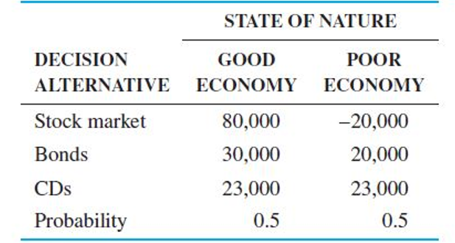
(a) What decision would maximize expected profits?
EMV for stock market = (0.5 x 80,000) + (-20,000 x 0.5)
= $30,000
EMV for bonds = (0.5 x 30,000) + (20,000 x 0.5)
=$25,000
EMV for CDs = (0.5 x 23,000) + (23,000 x 0.5)
= $23,000
The best alternative is the first one, investing in stock market.
(b) What is the maximum amount that should be paid for a perfect forecast of the economy?
The alternative for the state of nature of unfavorable market is do nothing and the expected monetary value with perfect information is given by:
EVPI = EVwPI – best EMV
Expected value with this perfect information is:
EVwPI = (80,000 x 0.5) + (23000, 0.5)
= $51,500
Therefore, with perfect information, the payoff will average 51,500 and thus EVPI will be
= 51,500 – 30,000
= $21,500
3-21 Develop an opportunity loss table for the investment problem that Mickey Lawson faces in Problem 3-20. What decision would minimize the expected opportunity loss? What is the minimum EOL?
To develop the opportunity loss table, we must find the best pay off for both good and poor economy.
For good economy we find the Maximax as follows:
 | State of Nature
Alternative | Good Economy | Poor Economy | Maximum
Stock Market | 80,000 | -20,000 | 80,000
Bonds | 30,000 | 20,000 | 30,000
CDs | 23,000 | 23,000 | 23,000
Probabilities | 0.5 | 0.5

From the above table, the best payoff for good economy is $80,000
For poor economy we find the Maximin as follows:
 | State of Nature
Alternative | Good Economy | Poor Economy | Maximum
Stock Market | 80,000 | -20,000 | -20, 000
Bonds | 30,000 | 20,000 | 20,000
CDs | 23,000 | 23,000 | 23,000
Probabilities | 0.5 | 0.5

From the above table, the best payoff for good economy is $23,000
The opportunity loss table is made as follows:
 | State of nature
Alternative | Good Economy | Poor economy
Stock Market | 80,000 – 80,000 = 0 | 23,000 – (-20, 000) = 43,000
Bonds | 80,000 - 30,000 = 50,000 | 23,000 - 20,000 = 3,000
CDs | 80,000 - 23,000 = 57,000 | 23,000 – 23,000 = 0
Probabilities | 0.5 | 0.5

The expected opportunity loss for each alternative is calculated as follows:
EOL for Stock market = (0.5 x 0) + (0.5 x 43000)
= 21,500
EOL for bonds = (0.5 x 50,000) + (0.5 x 3000)
= 26,500
EOL for CDs = (0.5 x 57,000) + (0.5 x 0)
= 28,500
The expected opportunity loss table for the investment will appear as follows:
 | State of nature
Alternative | Good Economy | Poor economy | EOL
Stock Market | 80,000 – 80,000 = 0 | 23,000 – (-20, 000) = 43,000 | 21,500
Bonds | 80,000 - 30,000 = 50,000 | 23,000 - 20,000 = 3,000 | 26,500
CDs | 80,000 - 23,000 = 57,000 | 23,000 – 23,000 = 0 | 28,500
Probabilities | 0.5 | 0.5

The minimum EOL is $21,500 and using the minimizing EOL as the decision criterion, the best alternative is investing in stock market.
3-24 Today's Electronics specializes in manufacturing ' modern electronic components. It also builds the equipment that produces the components. Phyllis Weinberger, who is responsible for advising the president of Today's Electronics on electronic manufacturing equipment, has developed the following table concerning a proposed facility:
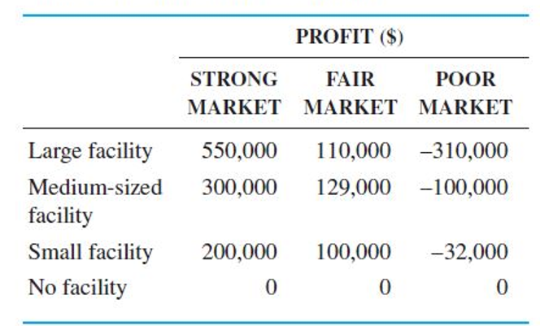
- Develop an opportunity loss table.
Opportunity loss table is made as follows:
 | Profits ($)
Alternative | Strong market | Fair market | Poor market
Large facility | 550,000 – 550,000 = 0 | 129,000 - 110,000 = 19,000 | 0 – (-310,000) = 310,000
Medium sized facility | 550,000 - 300,000 = 250,000 | 129,000-129,000 = 0 | 0 – (-100,000) = 100,000
Small facility | 550,000 - 200,000 = 350,000 | 129,000 - 100,000 = 29,000 | 0 – (-32,000) = 32,000
No facility | 550,000 – 0 = 550,000 | 129,000 – 0 = 129,000 | 0 – 0 = 0
Maximum payoff | 550,000 | 129,000 | 0

The final table will be as follows:
 | Profits ($)
Alternative | Strong market | Fair market | Poor market
Large facility | 0 | 19,000 | 310,000
Medium sized facility | 250,000 | 0 | 100,000
Small facility | 350,000 | 29,000 | 32,000
No facility | 550,000 | 129,000 | 0

- What is the minimax regret decision?
Using the opportunity loss table, find the minimax value
 | Profits ($)
Alternative | Strong market | Fair market | Poor market | Maximum
Large facility | 0 | 19,000 | 310,000 | 310,000
Medium sized facility | 250,000 | 0 | 100,000 | 250,000
Small facility | 350,000 | 29,000 | 32,000 | 350,000
No facility | 550,000 | 129,000 | 0 | 550,000

Then find the minimum of the maximum values, which is 250,000
Therefore, minimax regret decision would be a medium-sized facility
3-30 Even though independent gasoline stations have been having a difficult time, Susan Solomon has been thinking about starting her own independent gasoline station. Susan's problem is to decide how large her station should be. The annual returns will depend on both the size of her station and a number of marketing factors related to the oil industry and demand for gasoline. After a careful analysis, Susan developed the following table:
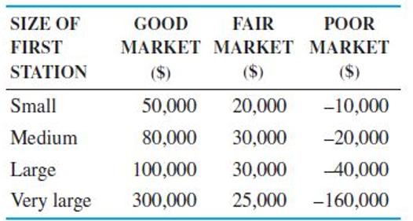
For example, if Susan constructs a small station and the market is good, she will realize a profit of $50,000.
(a) Develop a decision table for this decision.
 | State of nature
Alternative | Good Market | Fair Market | Poor Market
Small | 50,000 | 20,000 | -10,000
Medium | 80,000 | 30,000 | -20,000
Large | 100,000 | 30,000 | -40,000
Very large | 300,000 | 25,000 | -160,000

- What is the maximax decision?
 | State of nature
Alternative | Good Market | Fair Market | Poor Market | Maximum
Small | 50,000 | 20,000 | -10,000 | 50,000
Medium | 80,000 | 30,000 | -20,000 | 80,000
Large | 100,000 | 30,000 | -40,000 | 100,000
Very large | 300,000 | 25,000 | -160,000 | 300,000

The maximax decision is very large station with a value of $300,000
(c) What is the maximin decision?
 | State of nature
Alternative | Good Market | Fair Market | Poor Market | Minimum
Small | 50,000 | 20,000 | -10,000 | -10,000
Medium | 80,000 | 30,000 | -20,000 | -20,000
Large | 100,000 | 30,000 | -40,000 | -40,000
Very large | 300,000 | 25,000 | -160,000 | -160,000

The maximin decision is small station with a value of -$10,000
(d) What is the equally likely decision?
Under this criterion, each state of nature is assigned equal probability of occurrence and therefore, average profit is computed for each decision and then the maximum out of those is selected.
 | State of nature
Alternative | Good Market | Fair Market | Poor Market | Average
Small | 50,000 | 20,000 | -10,000 | 20,000
Medium | 80,000 | 30,000 | -20,000 | 30,000
Large | 100,000 | 30,000 | -40,000 | 30,000
Very large | 300,000 | 25,000 | -160,000 | 55,000

The maximum profit is in very large station, which is $55,000. Therefore, equally likely decision is to build Very Large station.
(e) What is the criterion of realism decision? Use an α value of 0.8.
Criterion of realism is a combination of Maximax and Maximin. According to α = 0.8, Optimism (Maximax) decision is given a weightage of 0.8 and pessimism (Maximin) a weightage of 0.2.
 | State of nature
Alternative | Good Market | Fair Market | Poor Market | Maximum | Minimum | Combination of Maximax and Maximin
Small | 50,000 | 20,000 | -10,000 | 50,000 | -10,000 | (0.8 x 50,000) + (0.2 x -10,000) = 38,000
Medium | 80,000 | 30,000 | -20,000 | 80,000 | -20,000 | (0.8 x 80,000) + (0.2 x -20,000) = 60,000
Large | 100,000 | 30,000 | -40,000 | 100,000 | -40,000 | (0.8 x 100,000) + (0.2 x -40,000) = 72,000
Very large | 300,000 | 25,000 | -160,000 | 300,000 | -160,000 | (0.8 x 300,000) + (0.2 x -160,000) = 208,000
 |  |  |  |  | Maximum | 208,000
The maximum payoff value is in very large station with a value of $208,000. Therefore, realism decision is to build very large station.
(f) Develop an opportunity loss table.
 | State of nature
Alternative | Good Market | Fair Market | Poor Market
Small | 300,000 -50,000 = 250,000 | 30,000 - 20,000 = 10,000 | -10,000 – (-10,000) = 0
Medium | 300,000 - 80,000 = 220,000 | 30,000 – 30,000 = 0 | -10,000 – (-20,000) = 10,000
Large | 300,000 - 100,000 = 200,000 | 30,000 – 30,000 = 0 | -10,000 – (-40,000) = 30,000
Very large | 300,000 – 300,000 = 0 | 30,000 - 25,000 = 5000 | -10,000 – (-160,000) = 150,000
Maximum | 300,000 | 30,000 | -10,000

The final opportunity loss table will be as follows:
 | State of nature
Alternative | Good Market | Fair Market | Poor Market
Small | 250,000 | 10,000 | 0
Medium | 220,000 | 0 | 10,000
Large | 200,000 | 0 | 30,000
Very large | 0 | 5000 | 150,000

(g) What is the minimax regret decision?
Based on the opportunity loss table to in part (f), the maximum of the values can be identified and then the minimum of the maximum values picked to identify the minimax regret decision.
 | State of nature
Alternative | Good Market | Fair Market | Poor Market | Maximum
Small | 250,000 | 10,000 | 0 | 250,000
Medium | 220,000 | 0 | 10,000 | 220,000
Large | 200,000 | 0 | 30,000 | 200,000
Very large | 0 | 5000 | 150,000 | 150,000

Based on the table above, the minimum opportunity loss is $150,000. Therefore, the minimax regret decision is to build a very large station.

